Programming projects laboratory

Students Marks application

Bernat Galmés Rubert

2016-2017

# User manual:

## Executing the code:

## Main menu screen:

When you have executed the program, you will see the next menu:

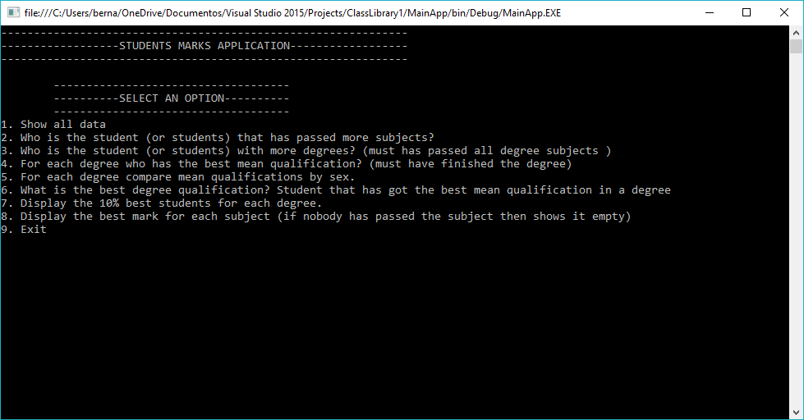

In this screen, you can choose between nine options:

1. Go to a menu to see the data that contains the application.
2. Consult the students with more subjects passed.
3. Consult the students with more degrees with all the subjects passed.
4. Consult the best mean qualification for each degree
5. Consult the mean qualification for each degree splitted by sex
6. Consult the Student/s with the best mean qualification in a degree
7. Display the 10% of the students with a best mean for each degree
8. Display all the subjects with their best mark
9. Quit the program.

To choose an option press the number in the left of the option and press enter.

## Consult data menu screen:

If you choose the first option, you will see the next screen:

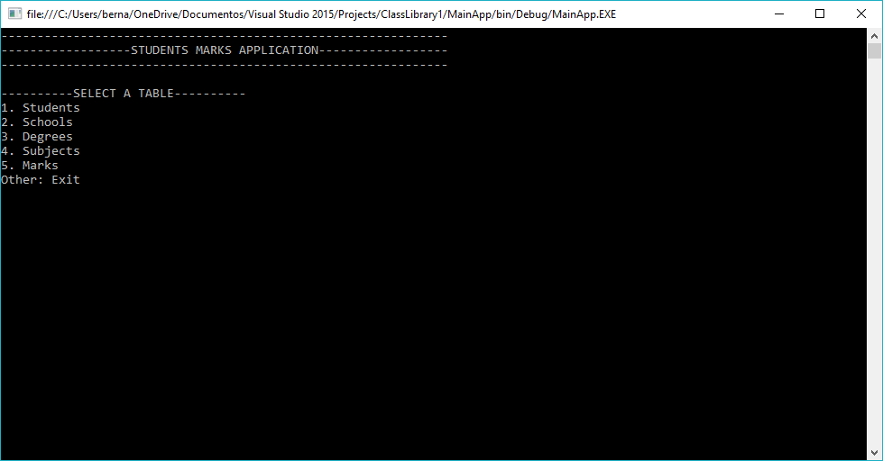

You have six options, you must press the number of the left of the option and press enter. After choosing an option you will see a table with all the data that the application has, for the selected item.

If you press a key different that numbers between 1 and 5 you go back to the main menu.

To exit from a table view you can press any key, and you go back to the main menu.

## Other options of the main menu:

If you choose an option different than the first and the last in the main menu, you will see on the screen the result of the query selected. To exit from a query view press any letter.

If you choose the last option(number 9) you will finish the program execution.

# Conclusions:

## Data generated:

The application are using randon data, but it can’t be a real random data. Because can happen that a student in the database hasn’t got any subject, or any mark… or a degree with no subjects…

Number of data:

To ensure that all the querys can have any results, we have to generate a coherent number of data.

We can define the number of schools and degrees. The number of the rest of the data are relative to the number of degrees.

Assigning subjects on a degree:

The subjects are assigned to a degree in a way that a degree can’t have the same subjects two times.

A student only can pass a subject one time:

To simplify the querys, the application have the constrain that a student only can pass a subject one time.

## Querys:

Developing the querys requires an initial effort implementing the three first. But, when you have acquired the dynamic the others are easy, and can reuse a lot of code.

The most difficult query is to get the list of the degrees passed for a student. Where you have to know if the set of subjects passed for a student contain all the subjects of a degree.